Gimnazjum z Oddziałami Dwujęzycznymi nr 14 im. Jana Gutenberga Fundacji Szkolnej,
ul. Obrzeżna 12a, 02-691 Warszawa, Poland
www.fundacjaszkolna.edu.pl
Meeting schedule
Slovakia Germany France Poland Italy Sweden
Greece Turkey Spain French Guiana
06-11.10.2014
06 October 2014 – arriving in Warsaw, meeting with students and their families
07 October 2014 – project day at school, lunch at school, tour around Warsaw – part 1: Łazienki Park, Nowy Świat, Krakowskie Przedmieście, the Royal Castle Square, dinner at the Zapiecek Restaurant opposite the Royal Castle
08 October 2014 – tour around Warsaw – part 2: the Warsaw Rising Museum; multiculturalism in Warsaw through centuries: the Old Town, the New Town, Barbican, Cathedral; dinner at the Old Town; looking for traces of multicultural heritage of the city: Polish, German, Jewish, Russian, Swedish cultural mixture;
09 October 2014 – project day at school, lunch at school, tour around Warsaw – part 3: visit to the centre of Warsaw: the Palace of Science and Culture (visit to the PKIN, panorama of Warsaw from the 30th floor), tour to Bankowy Square, Saski Garden, the Tomb of the Unknown Soldier, a farewell dinner
10 October 2014 – visit to a salt mine in Wieliczka – a UNESCO heritage site, dinner; visit to Krakow – the second largest city in Poland: tour around the Old Town: Wawel Castle, Sukiennice, Mariacki Church, urban game in the Old Town, back to Warsaw
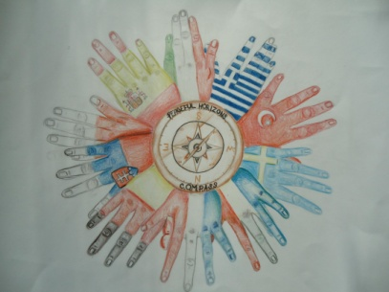
11 October 2014 – leaving day

