Meeting in Italy- Personal feedback - German point of view
According to the COMENIUS Handbook
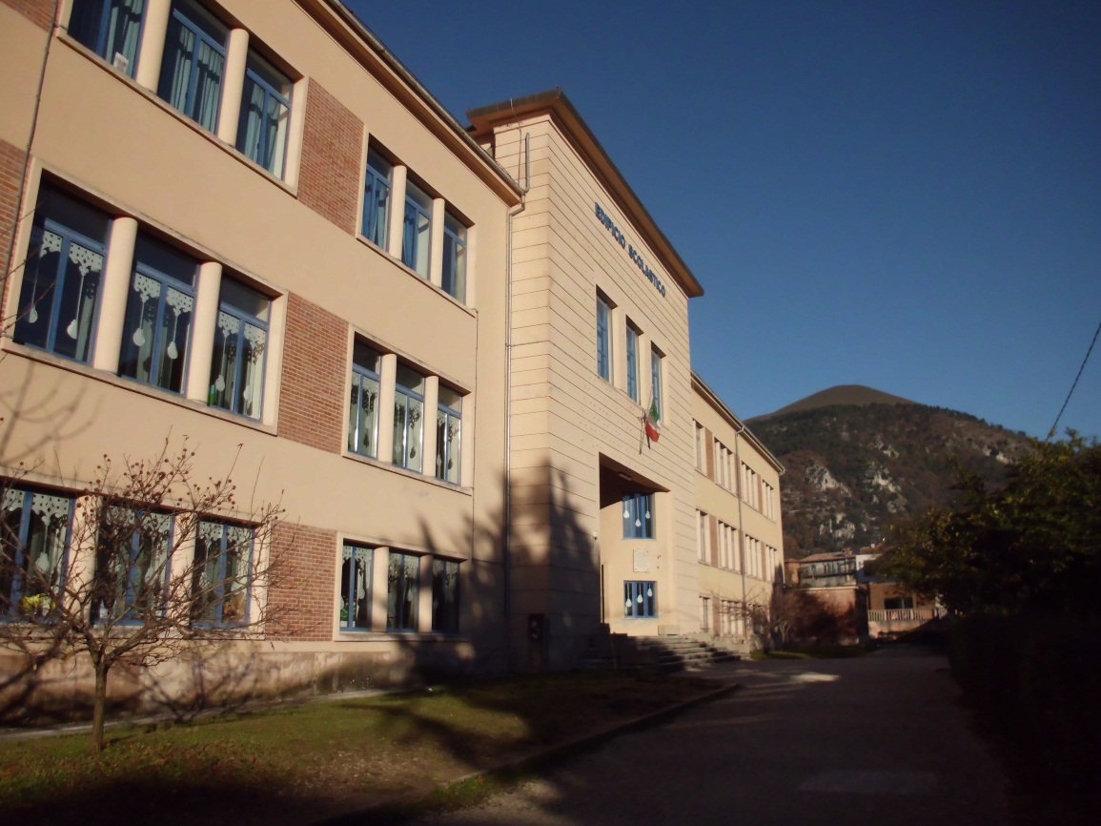
We were able to follow our intentions according to the work plan at this meeting. It was great to again see colleagues who had been in Sweden, to meet new ones and of course it was a great pleasure to meet pupils from each country and to make them become acquainted with each other. Yes, we were many and we all enjoyed the hospitality at school and in families as well as meeting as a team.
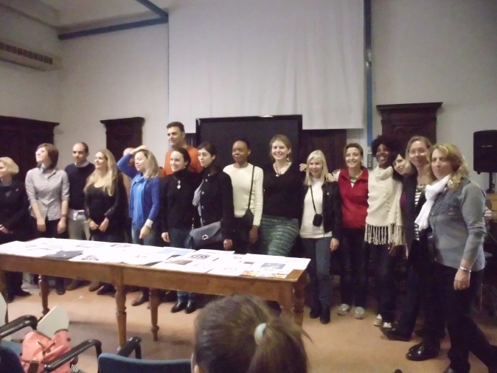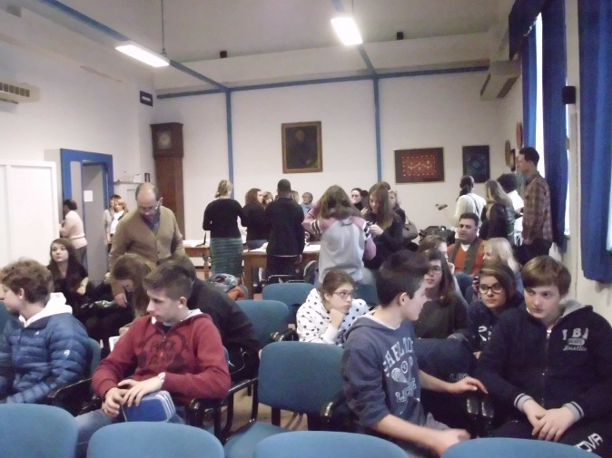
Our colleagues had done a great job in organizing our visit: a programme full of events inside and outside school. We had a great time and could experience our topic Celebrations in theory and practice, practice: the Italian way, quite new and unknown to all of us.
Unfortunately our team missed the first day as the plane could not land but returned to Germany after two attempts for landing. That is why we could not take part in the Christmas concert at school which must have been wonderful. We regret that we also missed the announcement of the winners of the Logo Competition, even if we learned about the result later. And unfortunately we could not take part in the work-groups when the work results of the time period since our first meeting in Sweden were presented and discussed.
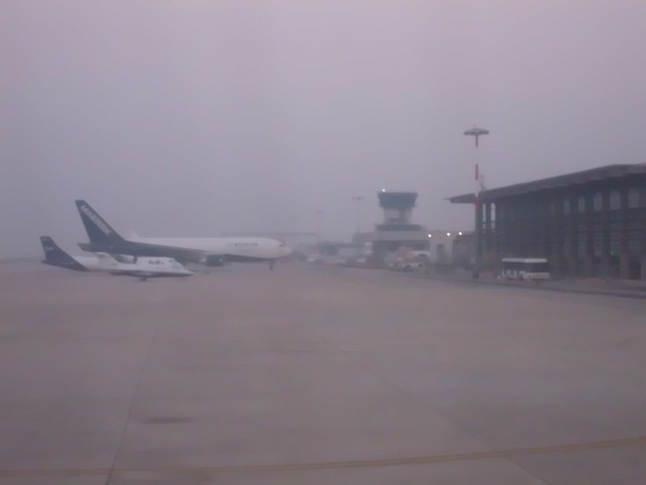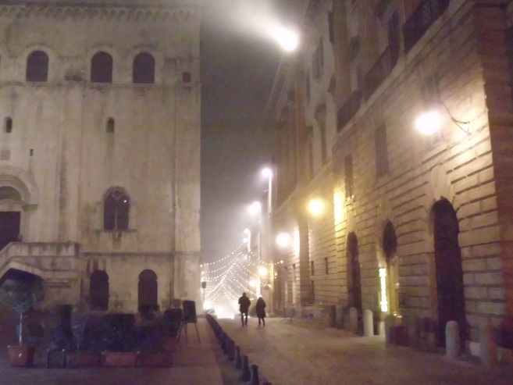
One day later – the weather was good enough for a landing in Ancona – we are very thankful that we were met at Ancona Airport and taken to Gubbio by car – we arrived not quite in time for the reception at the town hall.
In spite of that I consider our aims to be fulfilled. The completion of our material was successful, the ongoing process was discussed beforehand and regularly in our closed Facebook group and via email, results were collected and published in or linked to the Twinspace. Big thanks to our project coordinator who did not lose overview and did a lot of prep work to make it easier for the others to find their way – as well as reminding each of us to fulfill the tasks in time . And yes, they are appropriate.
The third meeting in France was discussed in detail and plans for the period until the end of March précised, according to our work plan. The next step, a survey about stereotypes, was finally discussed and completed, the first task after the Christmas holidays will be to have a considerable number of pupils answer the questions. We slightly changed the idea of another competition in drawing postcards with peace symbols, as a competition does not really reflect a peaceful attitude –but that is what we want to achieve within our pupils of so many countries.

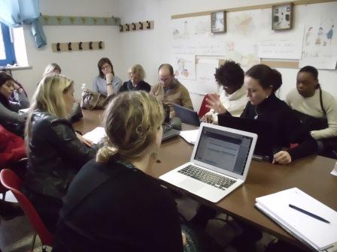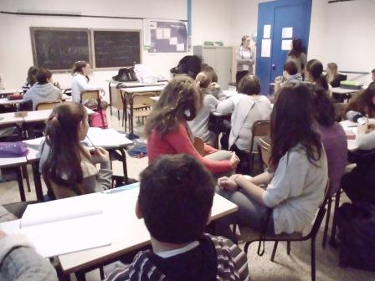
Socializing and relaxing a bit in the evenings– in very traditional and typical restaurants where we enjoyed excellent Umbrian cuisine offered in a very friendly and hospitable atmosphere in buildings dating back centuries ago.
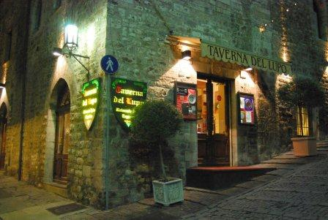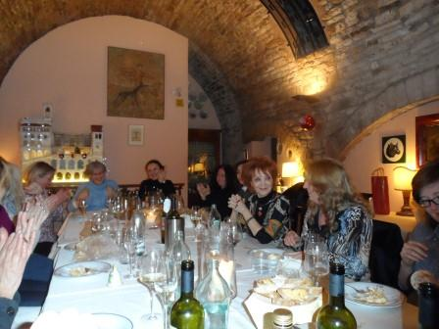

As the autumn holidays in Lower Saxony have just ended, there has been only an informal exchange of information with my pupils, they are eager to continue their work, as they have some experience with doing project work and sharing content on the etwinning Twinspace, they simply want to continue. By starting a new project, not only etwinning, but even COMENIUS, their motivation is held high and they choose from a variety of topics: either following their own ideas or preparing contributions to the general work plan of our project. Typical question: Is there anything to be done for our project?
And the prospects of maybe having the chance to take part in a COMENIUS meeting make some of my pupils work very hard, in their free time and in an extra project lesson at school, not only in the classroom lessons which are intended for project work.

